PAPER TITLE (Cambria font, capitals, size 18, max. 2 lines, single spacing throughout)
J. Z. Author & F. J. Kaiser. Regular font, font size 14
Tunneling company, Prague, Czech Republic Italic font, font size12
B. Author
New Tunnels, Wien, Austria
ABSTRACT: To ensure consistency of style throughout the proceedings, please prepare your paper exactly as indicated below. To facilitate your work, templates in English and Czech are available in docx format. Therefore, please use the "Abstract Field" so that the reader is fully informed about your article. The recommended word count for the "Abstract Field" should not exceed 300 words.

Chapter Title (First level headings are in bold capital letters size 14 and style 1. HEADING 1, 1 HEADING.)
Headings are aligned to the left margin. Style 1. HEADING 1,1 HEADING, two blank lines (24 pt.) above and one line below the text (12 pt.) are set. Headings and the first lines of text following the heading are not indented.

Subheading title (bold font, second level headings are renumbered relative to other first level heading, style 1.1. Heading 2, HEADING 2, left justified)
The format of the text of subchapter 1.1 HEADING 2, HEADING 2 is arranged in a single column, 18.7¬cm (7.36") wide. All text should be in Cambria 12 point font, with single line spacing. Never add any space between lines and paragraphs. (Normal style, To block alignment)

Subheading titles (Normal font, third-level headings are renumbered relative to their affiliation with second-level headings, style 1.1.1 Heading 3, heading 3, left-align. Do not use lower level headings in the paper).
Text format of subsection 1.1.1 Heading 3 is arranged in a single column, 18.7¬cm (7.36") wide. All text is in Cambria 12-point font, with single line spacing. Never add any space between lines and paragraphs. (Normal style, To block alignment).

ADDITIONAL GUIDELINES FOR WRITING THE PAPER

Starting the paper
Load the file PS_2026_Stemplate_CZ def. Name the file so that the first word is the last name of the first author, and the next word in the paper title is the first word of the paper title (e.g., for this paper: "AuthorName.doc(x)"). Now you can post your post or copy an old version of your post into this new formatted file where the styles are formatted.
Submit your paper in one of the Microsoft Word formats (doc, docx).

Figures and graphs
The figure is formatted in the "Figure" style. The title of the figure is in the form "Figure 1: Title of the first figure" and is placed below the figure, in the Figure caption style - the space between the figure and the text is part of the Figure style. The line containing the figure is placed in the center of the page when the Figure style is loaded. The figure must not be surrounded by text.
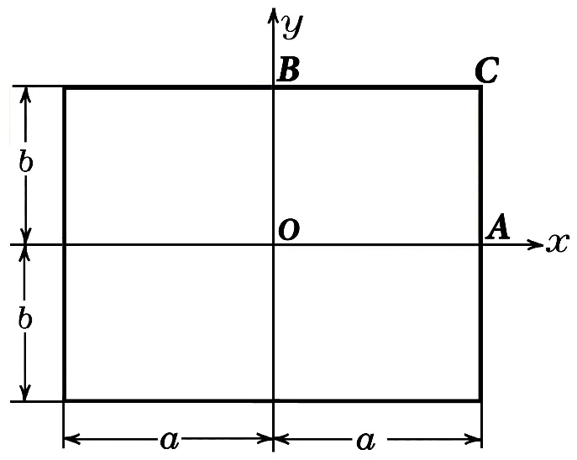
Figure 1: Place the caption below the figure. Insert only original photos (in case of *.jpg format with 300 dpi resolution). Always use the "Figure caption" style (size 9 with 11 point line spacing). Write as follows: 'Figure 1. Caption.' Insert one blank line between the figure caption and the following post text.

Tables
The table is indented at least 0.5 cm from the left and right edges of the text box and is cantered. The table must be referenced in the text. The caption is in the form "Table 1: Example Table", (Table caption style) and is placed above the table, left justified and has a space before the paragraph of 9 b and after the paragraph of 3 b. For text following the table (whether it is a continuation with a new paragraph or a heading), the space before the paragraph is set to 12 b, which is part of the Table style. The text of each cell in the table is in Cambria 10 b. Text in cells can be bolded or italicized (e.g., row or column headings) and justified as appropriate. Place the tables near the first mention of them in the text and number them as they go. Avoid abbreviations in column headings. Indicate units on the very next line below the header. Centre all column headers and begin these headers with a capital initial letter. It is a good idea to turn on the "Show All" function from the "Home" tab. See Table 1 for an example.
Table 1: Example table

Equation
Use the equation editor of the selected word processor program (e.g. in Word, tab "Insert > Symbols > Equations"). Equations are not indented from the edge of the text box (the style for equations is Formula,Equations). The spaces before and after the equation are 6 b., to the right of the formula near the right margin is its number in parentheses. The paragraph containing the equation is aligned to the centre for the equation.
Number the equations as they go and place the tab number at the end of the line, in parentheses. Refer to the equations by these numbers. Use the abbreviation alt+0215 for the multiplication sign (×). Equation (1) below:
From the above, we see that sin θ = (x + y)z or:
(1)
where k₀ = modulus of ground reaction, r_{o} = radius of excavation, Е = modulus of elasticity; ν_{o} = Poisson's number
Always use superscript and subscript for simple equations in the text. Do not use the equation editor within the text on a single line. We recommend inserting a non-printable ASCII control character between the numerals and the units and separating the units with the keyboard shortcut Alt+031.

Links to information sources, symbols and units
Information sources used are referenced in the Harvard system. If a name is mentioned in the text and the entire work is referenced: Novák (2007) talks about the construction of the subway or if we refer to part of the paper: Novák (2007, p. 25) assumes that . . . If the author's name is not directly mentioned in the text, then the following types of references are used: single author (Novák, 2007), two authors (Novák and Nováček 2001), multiple authors (Hromádko et al. 2010), author is an organization (CzTA 2015).
It is very important to maintain a consistent style. Note the spacing, punctuation and capitalization in all the examples below.
References in the text: Figure 1, Figures 2-4, 6, 8a, b (not abbreviated).
References in brackets: (Fig. 1), (Figures 2-4, 6, 8a, b).
U.S./U.K./Netherlands/ instead of the Netherlands, U.S.A., U.K., The Netherlands.
Author & Author (1989) instead of Author and Author (1989).
(Author 1989a, b; Author & Author 1987) instead of (Author, 1989a,b; Author and Author, 1987).
(Author et al. 1989) instead of (Author, Author & Author 1989).
Use the following style: (Author).
Always use the official SI system:
kg/m/kJ/mm instead of kg. (Kg)/m. / (KJ) / mm.
20°16′32′′SW instead of 20° 16′ 32′′ SW.
0.50 instead of 0.50 (used in French texts); 9000 instead of 9,000 if but greater than 10,000: 10,000 instead of 10,000.
14C instead of C14 / C-14 and BP / BC / AD instead of B.P. / B.C. A.D. / A.D.
×20 instead of ×20 / X20 / x20;
4+5>7 instead of 4+5>7 but -8 / +8 instead of -8 / +8.
e.g. / i.e. instead of e.g., / i.e.
Use the following reference signs: *, **, †, ††, etc. in a table, place a note immediately below the table.

Conclusion
CONCLUSION heading (First level headings are in bold capital letters size 14 and style 1. HEADING, HEADING 1 heading is left justified). The format of the "CONCLUSION" text is arranged in a single column, 18.7¬cm (7.36") wide. All text should be in Cambria 12 point font, single line spacing. Never add any space between lines and paragraphs. (Normal style, To block alignment).

ACKNOWLEDGEMENTS (BOLD, CAPITAL LETTERS)
The format of the text of the ACKNOWLEDGMENTS subsection is arranged in a single column, 18.7¬cm (7.36") wide. All text should be in Cambria 12 point font, with single line spacing. Never add any space between lines and paragraphs. (Normal style, To block alignment).
LITERATURE (bold, uppercase, REFERENCE HEADING style 12 point)
List all references in alphabetical order under the LITERATURE heading at the end of the paper. Sources are listed alphabetically by author or institution; citation format is according to ISO 690. A period is added at the end of the listing. If several works by the same author are cited, they are listed in chronological order. Style Reference text.
BARTÁK, J. and PRUŠKA, J. (2015). Numerical Models of Tunnels and Eurocode7. In: ITA WTC 2015. Zagreb: HUBITG, ISBN 978-953-55728-5-5.
ČEZ (2001). Annual report 2000. Praha: ČEZ.
DOCTOROW, C. (2008). Little Brother. London: Harper Voyager. ISBN 0007288427.
SCHWEIGER, H.F. (2010a). Numerical analysis of deep excavations and tunnels in accordance with EC7 design approaches. In: IInt. Conference Geotechnical Challenges in Megacities, 7.–10. 6. 2010 Vol. 1. Moscow: Geotechnical Society of Singapore (GeoSS). Research Publishing, pp. 206–217.
SCHWEIGER, H.F. (2010b). Nonlinear FE-analysis of tunnel excavation - comparison of EC7 design approaches. Geomechanics and Tunnelling. 2010, Vol. 3(1). pp. 61 - 67. ISSN 1865-7362.

((Include author(s) contact details at the end of the article, separated from the reference list by 1 free line)

Title, author's name, surname: Author1
Affiliation:
E-mail address:

Title, first name, last name of author: Author2
Affiliation:
E-mail address:

Deadline
Your paper should reach the publisher before the submission deadline. Submissions received after the deadline will not be published.

